**IT2120 - Probability and Statistics**

**Lab Sheet 09**

**IT24102799**

**Siriwardhana S.A.D.N**

Exercise

i)

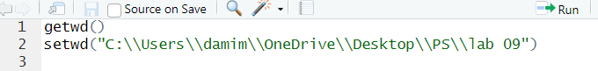

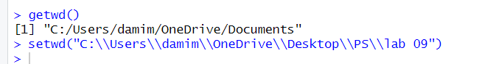

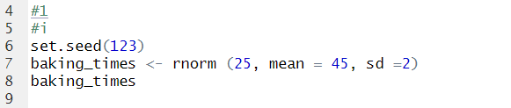

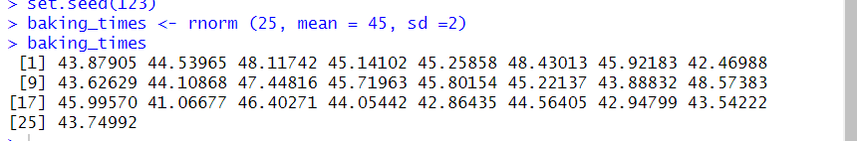

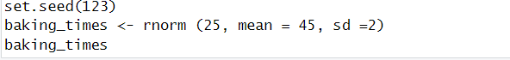

ii)

